**Book Signing at the library**

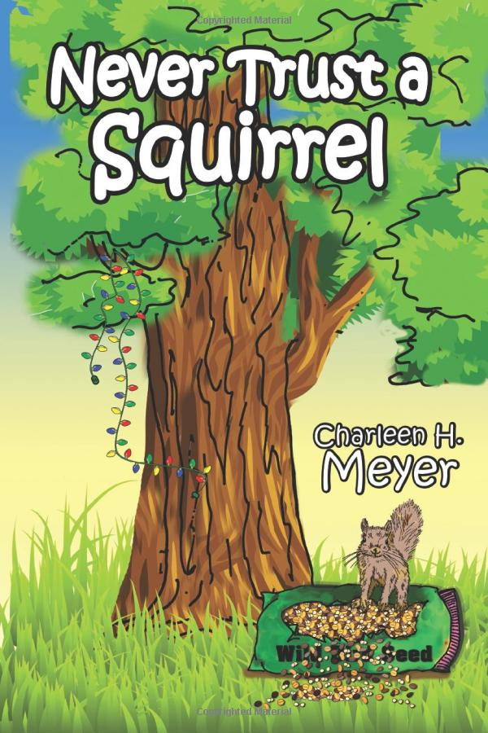

Carl and Martha love to sit on their back porch each day and watch squirrels squirreling around their country yard. Some are hunting for food for the winter, others like Nosey, who never helps, but just gets into trouble. Then there is Foxy and Andy who have their own ideas. Milford the cat is taken in by Martha who distracts him from the squirrels. Finally, Carl and Martha realize you can never trust a squirrel.

On July 11th from 10-12, the library will host a book signing for Charleen Meyer’s new book: “Never trust a squirrel”. Charleen is a local author. The library has several of her older books as well. Stop by to see Charleen and her new book!